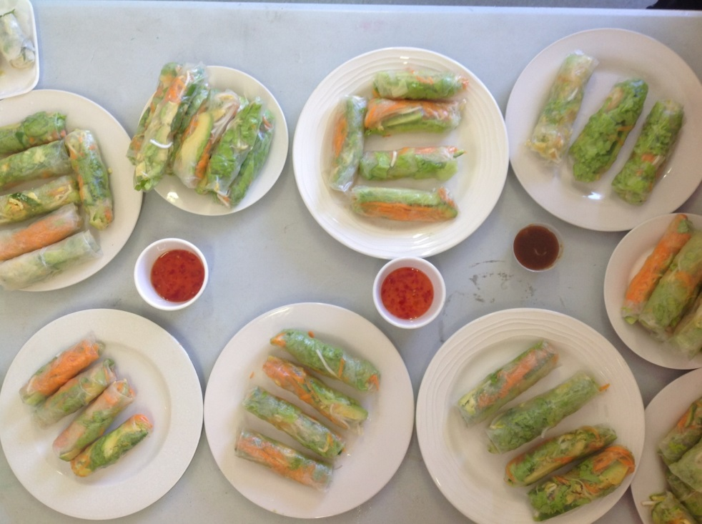**Vegetarian Rice-Paper Rolls**

*Servings: 4*

**INGREDIENTS**

* 8 rice-paper wrappers
* 1 cup of lettuce, shredded
* 1 cup of beansprouts, trimmed
* 1 carrot, grated
* 1 Lebanese cucumber, peeled
* 1 avocado, sliced
* sweet chilli sauce

**METHOD**

1. Pour warm water into a bowl until half full.
2. Dip 1 rice-paper wrapper in the water.   
   Let it stand for 30 seconds (until soft).
3. Place the lettuce along the edge of the wrapper.   
   Add beansprouts, carrot, cucumber and avocado.
4. Fold in the ends and roll up firmly.
5. Repeat, then serve with sweet chilli sauce.